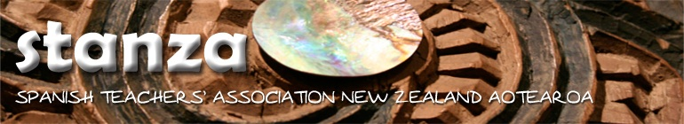

Video Competition 2022
for Year 9 and 10 students

SHOW US WHAT YOU’VE LEARNT!

Theme: Mitos y leyendas. You will retell a myth or legend of your choosing. For example, it could be a Maori myth or legend or a myth or legend from the Spanish-speaking world. This is up to you.
Deadline: 21st November 9:00am
Entry: Upload the video on your Google Drive and send the link to Cheryl van Dijck cheryl.vandijck@stcuthberts.school.nz

Prize for First place: $100 for celebratory end-of-year treats.
PLEASE NOTE: Due to the late date of the competition the winning school will have to provide the treats at the end of the year. You will be reimbursed before the end of term.

Video specifications:

3 minutes maximum in length. The students may do their own acting or use animated characters and drawings, but there must be more than one participant speaking in the video.

Submission Guidelines

1. Participation is limited to students in Years 9 and 10
2. Students should not be native speakers of Spanish.
3. Limit of two submissions per school.

Judging Criteria
1. Content 40%: Be sure the content of your video addresses the theme but remember you can be as creative with this as you want to be.
2. Creativity 20%
3. Language 40%: Students should use Spanish in their recordings.

